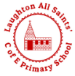
Design and Technology at Laughton All Saints’ C of E Primary School
Design and Technology at Laughton All Saints’
D&T gives children the opportunity to develop skills, knowledge and understanding of designing and making functional products. We feel it is vital to nurture creativity and innovation through design, and by exploring the designed and made world in which we all live and work.

Design and Technology at Laughton All Saints’
Design and Technology education involves two important elements – learning about the designed and made world and how things work, and learning to design and make functional products for particular purposes and users. Children acquire and apply knowledge and understanding of materials and components, mechanisms and control systems, structures, existing products, quality and health and safety.
The skills learned in D&T also help with learning across the curriculum. Knowledge about the properties of materials helps in science and the practice of measuring accurately helps in maths. These skills help in computing through the children’s use of computer control and, naturally, in art and design.
Design and Technology education helps develop children’s skills through collaborative working and problem-solving, and knowledge in design, materials, structures, mechanisms and electrical control. They are encouraged to be creative and innovative, and are actively encouraged to think about important issues such as sustainability and enterprise.
There are three core activities children engage with in Design and Technology:
- Activities which involve investigating and evaluating existing products
- Focused tasks in which children develop particular aspects of knowledge and skills
- Designing and making activities in which children design and make ‘something’ for ‘somebody’ for ‘some purpose.’
These three activities are combined in sequence to create a Design and Technology project.

Why is D&T important to our school?
Design and Technology is about providing opportunities for children to develop their capability. By combining their design and making skills with knowledge and understanding they learn to create quality products.
D&T is often one of a child’s favourite subjects. Children like making decisions for themselves and doing practical work. They love creating products they can see, touch – and even taste – for themselves. They feel proud to have done so.
D&T brings learning to life. It is a motivating context for discovering literacy, mathematics, science, art, PSHE and ICT. Primary Design and Technology also provides a firm basis for later learning in the subject and a platform for developing skills in literacy and numeracy.

Curriculum Design
At Laughton All Saints’ we follow the National Curriculum, which includes Design and Technology as a compulsory subject at Key Stages 1 and 2, with statutory Programmes of Study. To implement the national curriculum, we use Projects on a Page. This is a scheme that has been carefully designed by the Design and Technology Association (DATA). We are proud members of DATA, using their expertise and research to give our children rich design and technology experiences.

Projects on a Page
The scheme of work is based on universal principles of effective teaching and learning in D&T.
Why did our school choose Projects on a Page?
• Flexibility and less prescription – teachers, in discussion with the children in their class, decide what products they will design and make, who their products will be for and what purposes they will perform.
• The Project Planners are context-free to make it much easier to link D&T to cross-curricular topics or themes.
• Essentials of good practice in D&T – each Project Planner emphasises the essentials of good practice in D&T to ensure children receive a genuine D&T experience.
• Projects on a page – all the elements or ‘building blocks’ of a project can be seen together on one side of the Project Planner.
• Instant CPD – on the other side of the Project Planner is user-friendly guidance with sketches, diagrams, tips and techniques.

Design and Technology Essentials
Projects on a Page is based on the six essentials of good practice in D&T. These need to be in place in teachers' planning to ensure children’s learning is genuinely design and technological in nature. They are consistent with the National Curriculum requirements and should be applied whenever children are designing and making products:
• User – children should have a clear idea of who they are designing and making products for, considering their needs, wants, interests or preferences. The user could be themselves, an imaginary character, another person, client, consumer or a specific target audience.
• Purpose – children should know what the products they design and make are for. Each product should perform a clearly defined task that can be evaluated in use.
• Functionality – children should design and make products that function in some way to be successful. Products often combine aesthetic qualities with functional characteristics. In D&T, it is insufficient for children to design and make products which are purely aesthetic.
• Design Decisions – when designing and making, children need opportunities to make informed decisions such as selecting materials, components and techniques and deciding what form the products will take, how they will work, what task they will perform and who they are for.
• Innovation – when designing and making, children need some scope to be original with their thinking. Projects that encourage innovation lead to a range of design ideas and products being developed, characterised by engaging, open-ended starting points for children's learning.
• Authenticity – children should design and make products that are believable, real and meaningful to themselves i.e. not replicas or reproductions or models which do not provide opportunities for children to make design decisions with clear users and purposes in mind.
The six essentials are embedded into the Project Planners, each of which has suggestions for users and purposes, and a list of authentic products that children could design and make. Each Planner has a star diagram that enables you to evaluate the overall potential of the project to ensure each of the D&T essentials has been addressed. Different projects will have a different profile.

Long Term Planning
• We ensure that each term’s project addresses a particular aspect of the subject. In EYFS and KS1, these are mechanisms, structures, food and textiles, and at KS2 mechanical systems, electrical systems, structures, food and textiles.
• We have developed progressive KSV (knowledge, skills and vocabulary) documents. These identify what children should have learnt in the previous years before carrying out a project.

Design and Technology in the Early Years Foundation Stage
Laughton All Saints’ KSV specifically identify what children should learn in EYFS. To support the teacher’s planning we have used exemplary projects from the Design and Technology Association.
Children’s experience of D&T in the EYFS may have included some or all of the following elements:
• Designing by talking about what they intend to do, are doing and have done.
• Saying who and what their products are for.
• Drawing what they have made, with some children drawing their ideas before they make.
• Opportunities to make their own choices and to discuss the reasons for these.
• Learning procedures for safety and hygiene.
• Developing practical skills and techniques using a range of materials including food, textiles and construction materials.
• Developing their knowledge and understanding in relation to mechanisms, structures, food and textiles.
• Exploring and using a range of construction kits.
• Asking questions about a range of existing products.
• Exploring the designed and made world through the indoor and outdoor environment, and through roleplay.
• Learning and using appropriate technical vocabulary.

Assessment and Progression
Children at Laughton All Saints’ have a strong design and technology subject knowledge, each year we build on concepts equipping our children for secondary school. Projects on a Page enables school to check what children have learnt and determine whether they are on track to meet National Curriculum expectations by the end of each key stage. At Laughton All Saints’ we have further developed projects on a page and created end of year knowledge documents. These documents outline the important knowledge that we expect children to know and remember. To help this knowledge stick, we regularly quiz our children using retrieval strategies. Our D&T lead regularly tests children’s subject knowledge to judge the quality of teaching.
End of Year Knowledge Document
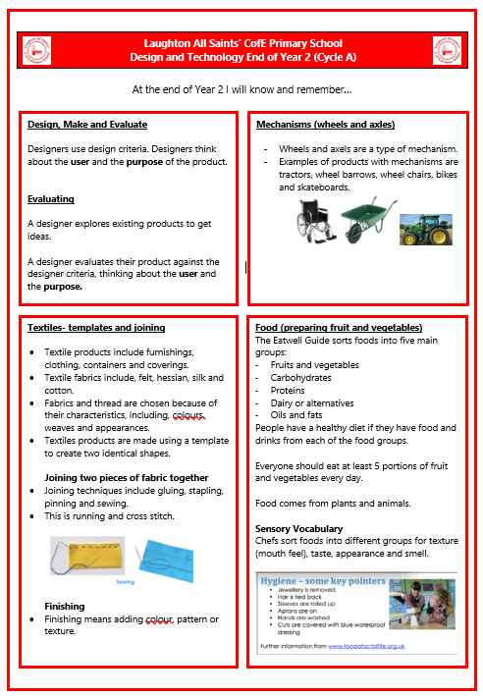

Using the Project Planners
Building a picture of what children know, understand and can do in each D&T project is essential for moving their learning forward. Each planner lists the ‘key learning’ in designing, making, evaluating and technical knowledge and understanding that most children should develop as they undertake the project. This addresses and extends National Curriculum requirements at KS1 and 2 and are consistent with the Progression Framework.
The knowledge, understanding and skills specified in key learning forms the basis of learning objectives for each D&T session and is used to help focus teacher’s discussions with children and inform observations. The information gathered during projects about the performance of individual children and groups, enables teachers to provide carefully tailored feedback, questioning, explanation and support, according to their needs. When each project has been completed, we make a note of the children who have not reached the expected standard, or have gone above, and we use this information to offer additional support or challenge, as required, in the next project they carry out.

The Progression Framework
The Progression Framework provides a series of developmental steps intended to help teachers with curriculum planning. It also help us to assess whether children are on track to meet end of key stage expectations in the National Curriculum. The Framework comprises age-related expectations across KS1 and KS2, with specific expectations for early KS2 (Y3/4) and late KS2 (Y5/6). Importantly, the framework also includes elements of D&T which are not included in the programmes of study which are considered by the Design and Technology Association to be fundamental to children’s learning in KS1 and 2.
The Framework works most effectively if a cumulative approach to progression is adopted. This means that, where appropriate, children’s learning from KS1 is revisited in early KS2 and their learning from KS1 and early KS2 is revisited in late KS2, each time using the knowledge, understanding or skills in a more sophisticated way. This is particularly relevant for aspects of learning that are only mentioned once but would need to be re-visited e.g. using mock-ups only appears in KS1 but should also feature in children’s learning in KS2. A clickable version of the progression framework with extended features is available to us as members of the Association.

